

**Exploratory Sales Analysis of THE MAVEN TOYS**

Report by: Farrukh Nizam Arain  
Designation: Data Analyst  
Date: 28th February 2023

**Introduction:**Mexico-based Maven Toys is a fictious international toy retailer that also sold clothing, video games and baby products. Founded in 1948 by Diego Lazarus, the retailer was a major player in the toy business for over 65 years, until online giants like Amazon started eating into the market share in recent years.  
After filing for bankruptcy in September 2017, Maven Toys announced that it would be closing all its US and UK stores in 2018. All 100 stores in the UK closed in April 2018 and remain closed. **Problem Statement:**  
The purpose of my assessment in this project is to answer the questions below by analyzing the different aspects of sales data in the Emirates Airlines, including information about products, stores, daily sales transactions, and current inventory levels at each location.   
  
The important questions were:

1. Which product categories contributed to the biggest total profits in the last 2 years?
2. Which product categories were most popular among consumers?
3. Is it possible to find any possible seasonal trends or patterns in the sales data?
4. What is the contribution of the stores to generating profits?
5. Which stores had the highest and lowest profits generated?
6. What is the contribution of profits as per store location?
7. What is the current amount of inventory in the warehouse?
8. What is the total contribution of profits per store location?
9. Which stores have the most items in inventory to be sold?
10. Which stores had the least number of profits generated?

**Preparation of the Datasets:**Public datasets were downloaded at the following [link](https://www.mavenanalytics.io/data-playground?page=4&pageSize=5) provided by Maven Analytics under this [license](https://www.mavenanalytics.io/terms-for-individuals). No issues with bias and credibility were found with the data through the methodology of ROCCC.

Following are the list of files (in CSV format) and the descriptions:

|  |  |
| --- | --- |
| Filename | Description |
| inventory.csv | Inventory of the toys |
| products.csv | List of items offered |
| stores.csv | Number of stores |
| Sales.csv | Sales data in between 2017 and 2018 |

**Processing of the Datasets:**

The tools that I used for data processing are:

* Microsoft Excel 365
* Power Query Editor
* Power Pivot

To remove any ambiguity of the fields used in the database, I created a data dictionary of the initial datasets to make it easier for the reader to better understand it.

**Inventory Dataset:**



**Products Dataset:**

**Sales Dataset:**  
  
  
**Stores Dataset:**  




**Preparation of the Datasets:**Overall, I dd not find any major issues when it comes to cleaning the dataset before I proceed to the next stage of analysis of the dataset. However, I took following steps using Power Query Editor and Power Pivot:

* I removed all the underscores in the column names to increase the readability of columns.
* I deleted the numbers in the store names column by splitting the column and deleting the column which had incorrect data.  
    
  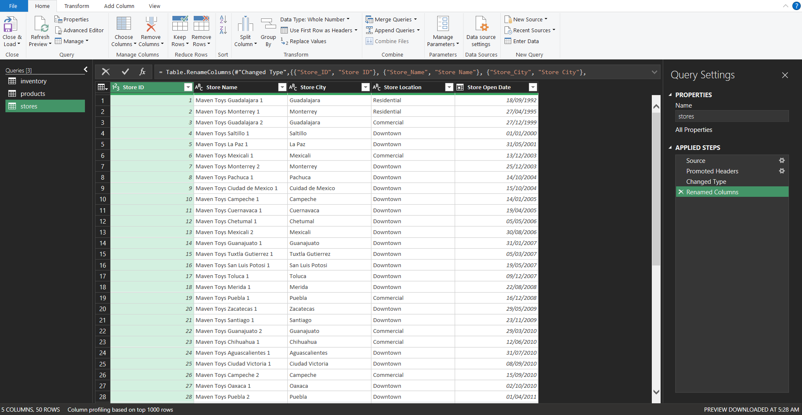
* An index column was added in the inventory column to have a uniqueness of every row of record.  
    
  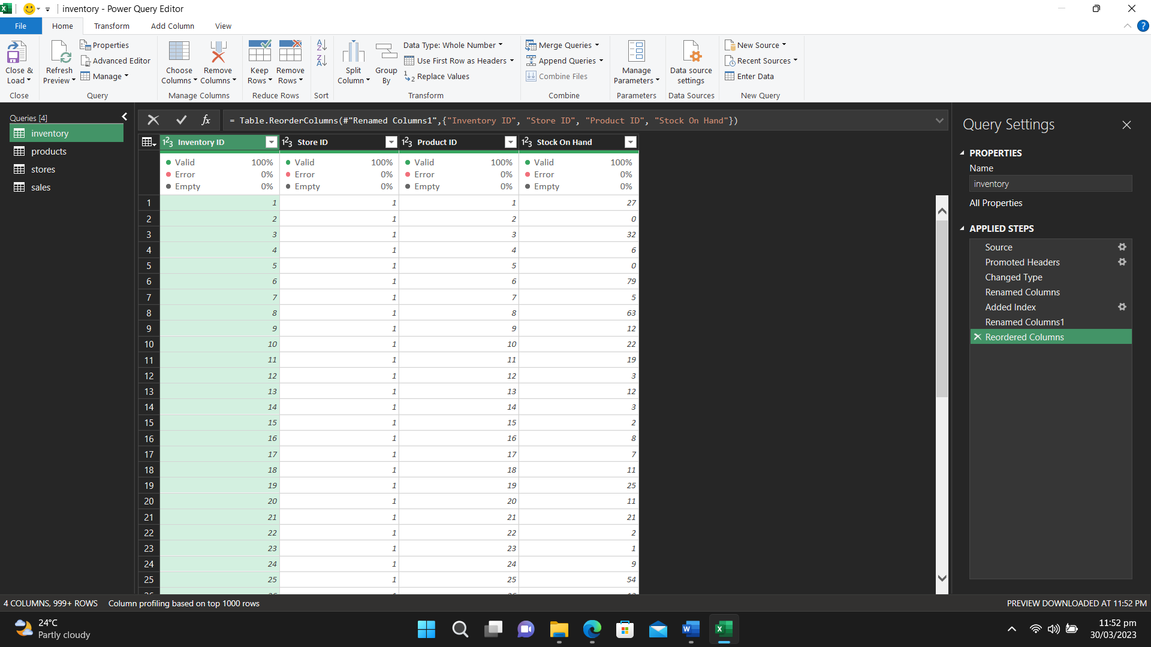
* To create profits earned through the unit sales of different products, I used this simple formula to calculate values from the tables of sales and products:  
    
  = (sales[units] * products [products price]) – products[products cost]
* For figuring out the amount which we have invested in manufacturing the items and are in the inventory, I merged the queries via multiplying the units in the inventory with the manufacturing cost vis this formula.  
    
  = [Stock On Hand] * [Cost]
* Finally, I created relationships between the all the four tables before starting the analysis phase.

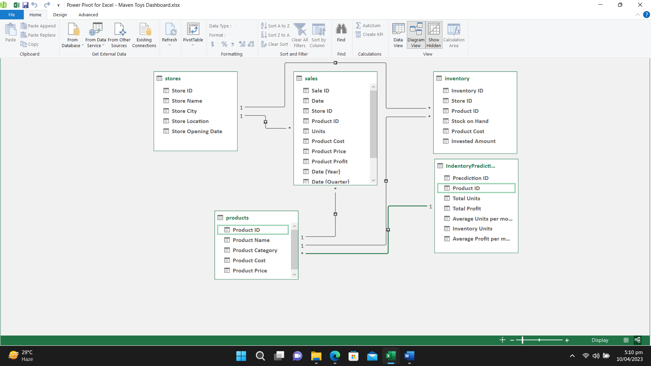

**Analysis of the Datasets:**  
Following are the queries raised by the stakeholders and the related tabular and visualized representation of insights that were found:

1. **Which product categories contributed to the biggest total profits in the last 2 years?**  
   Since the last two years, unsurprisingly toys contributed the most when it comes to profitability for the company, with items of Electronics and Arts & Crafts on the 2nd and 3rd place, respectively.

|  |  |
| --- | --- |
| **Item Types** | **Sum of Product Profit** |
| Art & Crafts | $1,271,718.99 |
| Electronics | $1,283,326.50 |
| Games | $952,373.33 |
| Sports & Outdoors | $842,881.88 |
| Toys | $1,821,172.27 |
| **Grand Total** | **$6,171,472.97** |

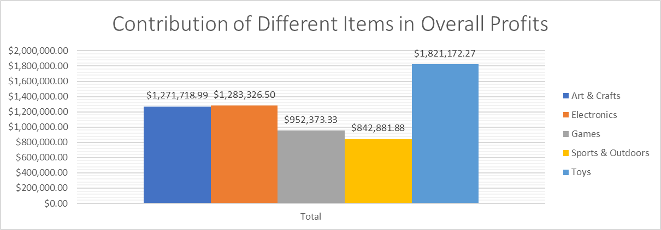

1. **Which product categories were most popular among consumers?**  
   In the previous analysis, we came to know the cumulative profits generated by all the product categories. However, it was also imperative to spot any trends much more minutely of them.   
     
   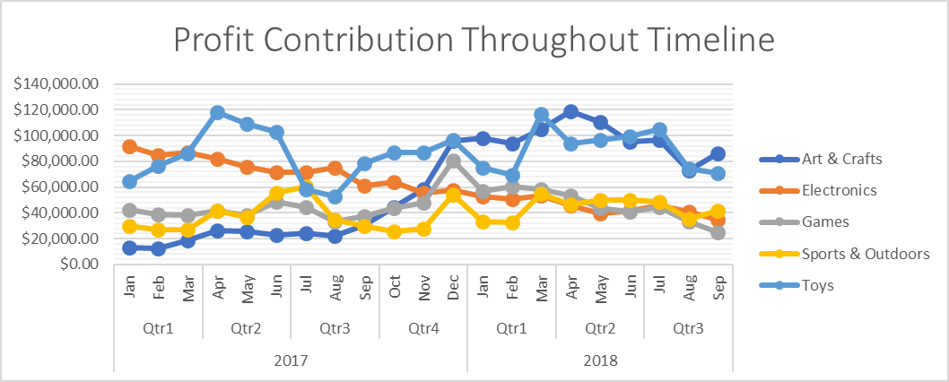  
     
   Even without going through the number of profits generated individually, it can be easily observed that artis and crafts, and toys generated the bulk of profits. Especially, the demand for toys gradually increased from August 2017 and maintained its popularity till January 2018.   
     
   On the other hand, products under Electronics started strong with profits worth $100,000, but then started declining immediately after that. The items under games, and Sports & outdoors also didn’t contribute much to the overall profit for the organization.
2. **Is it possible to find any possible seasonal trends or patterns in the sales data?**  
   Regarding seasonal trends, analysis was a bit tricky and time consuming because I had to observe different variables to come up with analysis.

|  |  |  |  |
| --- | --- | --- | --- |
| **Years** | **Sum of Units** | **Sum of Product Cost** | **Sum of Product Profit** |
| **2017** | **549492** | **$4,205,543.55** | **$3,276,954.53** |
| **2018** | **541073** | **$4,067,555.83** | **$2,894,518.44** |
| **Grand Total** | **1090565** | **$8,273,099.38** | **$6,171,472.97** |

In the tabular data, it was impossible to observe any trends so the line plot below helped me analyze and come up with some analysis which would benefit the organization.  
  
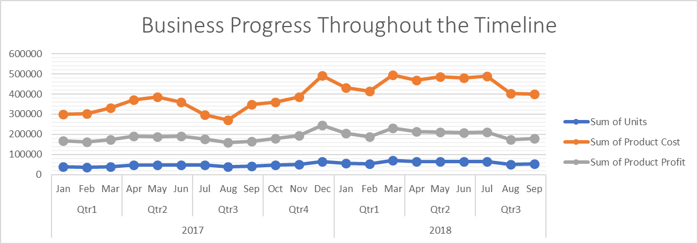  
  
Unfortunately, the cost of production for all the items is nearly **50 percent more** than the profits generated. Especially, the cost increased from just under $40,000 to just above $50,000 in a matter of months. Additionally, the number of units sold has maintained a steady line throughout the timeline of the sales data which was provided.

1. **What is the contribution of the stores for generating profits?**  
   Regarding the importance of store’s locations, the ones in the downtown area contributed to **56.021 percent** of the total profits. The rest of the locations maintained their contribution and did not even cross the barrier of even $60,000 of profits in any month.

|  |  |  |  |  |  |
| --- | --- | --- | --- | --- | --- |
|  | **Airport** | **Commercial** | **Downtown** | **Residential** | **Grand Total** |
| **Years** |  |  |  |  |  |
| **2017** | **$205,010.00** | **$517,899.00** | **$1,217,908.00** | **$248,970.00** | **$2,189,787.00** |
| **2018** | **$173,039.00** | **$408,965.00** | **$1,030,820.00** | **$211,418.00** | **$1,824,242.00** |
| **Grand Total** | **$378,049.00** | **$926,864.00** | **$2,248,728.00** | **$460,388.00** | **$4,014,029.00** |

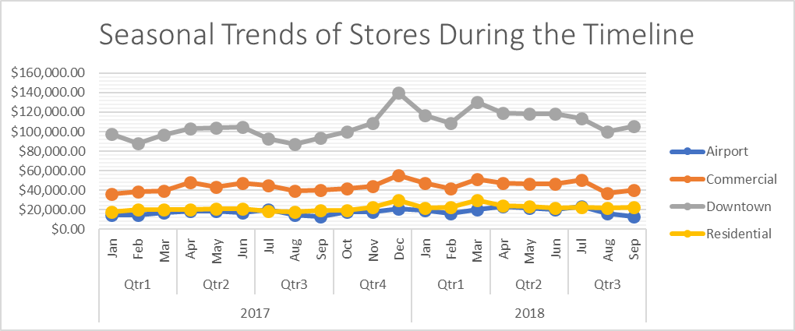

1. **Stores with the highest and lowest profits generated?**  
   The tabular data presents the top ten stores with the highest profits generated, with the store in Ciudad de Mexico topping the list with generated profits of over $450,000.

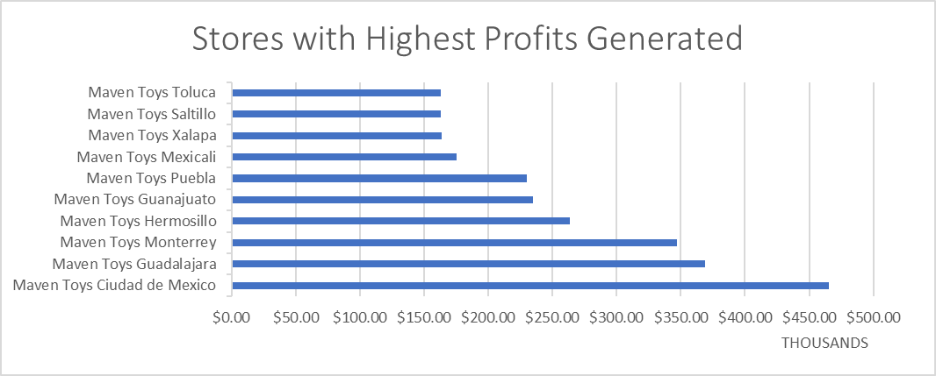

Furthermore, the following are the names of the stores having the lowest profitability for the sales of different items.

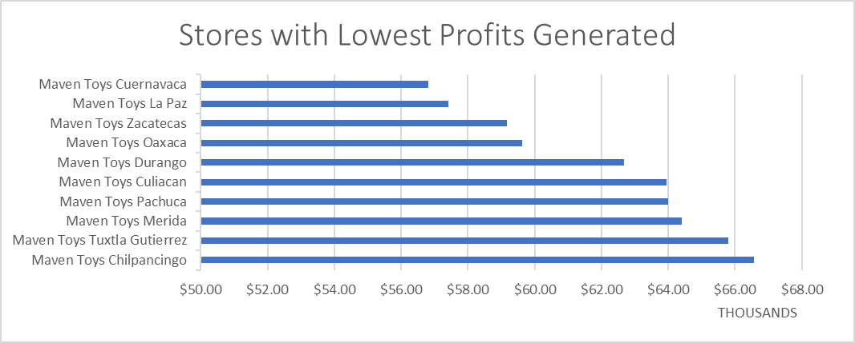

1. **What is the contribution of profits as per store locations?**  
   As per the analysis, the stores in downtown accumulated more than $2,000,000 of profits in the last 2 years. Surprisingly, stores in the rest of the locations didn’t contribute much, except for communal area stores which collected profits of just under $ 950,000.

|  |  |
| --- | --- |
| **Store Locations** | **Sum of Product Profit** |
| Airport | $378,049.00 |
| Commercial | $926,864.00 |
| Downtown | $2,248,728.00 |
| Residential | $460,388.00 |
| **Grand Total** | **$4,014,029.00** |

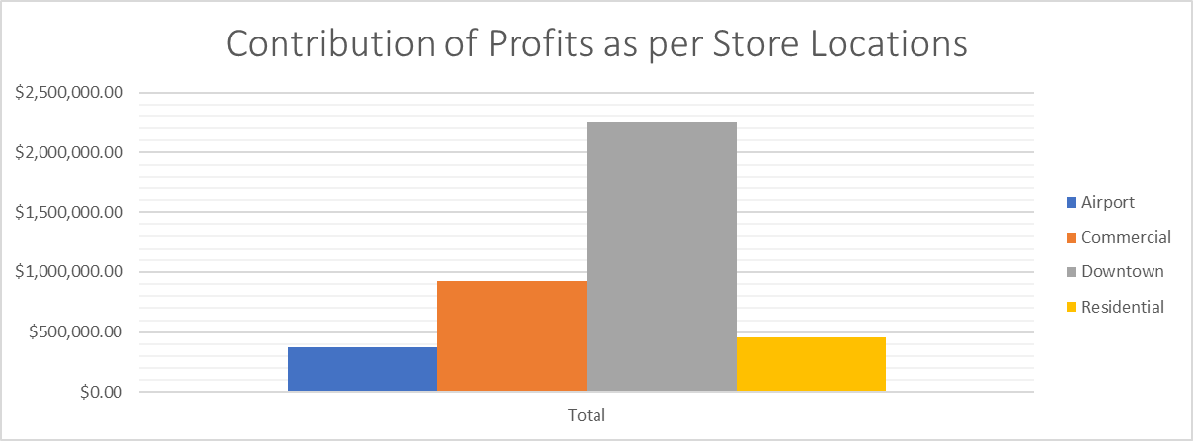

1. **What is the current amount of inventory in the warehouse?**  
   Currently, around $300,000 worth of products are in warehouse, with major chunk of investment is rightly spent in buying Toys of $99,861.47. Second place comes up with the products coming under the category of Arts & Crafts, which is worth $65,075.65. The other three categories did not have many products left in the warehouse.

|  |  |  |
| --- | --- | --- |
| **Product Categories** | **Sum of Invested Amount** | |
| Art & Crafts | | $65,075.65 |
| Electronics | | $30,705.82 |
| Games | | $51,489.45 |
| Sports & Outdoors | | $53,077.19 |
| Toys | | $99,861.47 |
| **Grand Total** | | **$300,209.58** |

Inventory situation with a bar plot will further clarify the standing of the items in the warehouse for understandings.

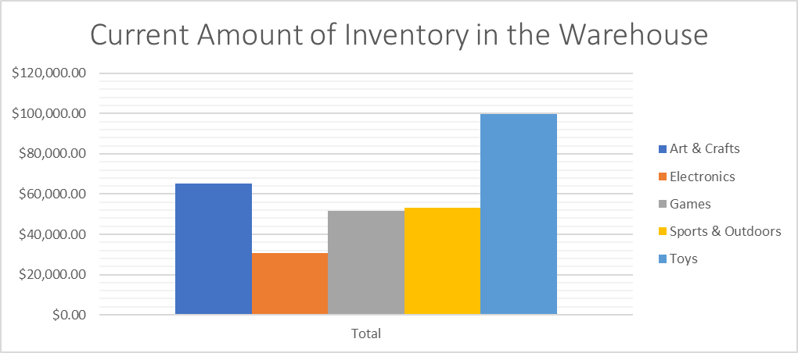

1. **What is the total contribution of profits as per store locations?**  
   If we analyze the total profit contribution of stores in specific areas, downtown took the lead with profits of more than **50 percent** of the grand total, amounting to more than $2,000,000 during the two years. The alarming situation is that the rest of the store locations did not contribute much, and the most profitable location was of the stores in commercial areas, but even those stores ended up just less than $1,000,000 profits.  
     
   
2. **Which stores have the most items in the inventory to be sold?**  
   To minimize the cost to maintaining inventory of products in the stores, the list of stores was analyzed. The following had the most products lying around in the inventory:

|  |  |
| --- | --- |
| **Store Names** | **Sum of Stock on Hand** |
| Maven Toys Ciudad de Mexico | 2681 |
| Maven Toys Guadalajara | 2331 |
| Maven Toys Hermosillo | 2232 |
| Maven Toys Monterrey | 2227 |
| Maven Toys Guanajuato | 1596 |
| Maven Toys Chihuahua | 1478 |
| Maven Toys Puebla | 1328 |
| Maven Toys Campeche | 1238 |
| Maven Toys Mexicali | 1222 |
| Maven Toys Saltillo | 1144 |
| **Grand Total** | **17477** |

1. **Which stores had the least number of profits generated?**  
   Below are the least profitable stores of Maven Toys:

|  |  |
| --- | --- |
| **Toy Stores** | **Sum of Product Profit** |
| Maven Toys Chilpancingo | $66,558.00 |
| Maven Toys Tuxtla Gutierrez | $65,787.00 |
| Maven Toys Merida | $64,399.00 |
| Maven Toys Pachuca | $63,989.00 |
| Maven Toys Culiacan | $63,959.00 |
| Maven Toys Durango | $62,673.00 |
| Maven Toys Oaxaca | $59,618.00 |
| Maven Toys Zacatecas | $59,160.00 |
| Maven Toys La Paz | $57,407.00 |
| Maven Toys Cuernavaca | $56,811.00 |
| **Grand Total** | **$620,361.00** |

A bar plot will further describe the amount generated by the stores which did not contribute much in the overall profitability of the company.  
  


**Conclusion of the Analysis:**  
During this project, I analyzed the sales results of a fictious The Maven Toys to not only extract and analyze the trends and patterns, but also suggested actions based on data for better profitability for the company.  
  
After having several meetings with all the stakeholders and analysis of the relevant datasets, the following recommendations are made:

1. As per the datasets provided, products under the categories of games, and sports and outdoors aren’t contributing much to the profitability of the company. It is imperative that stakeholders should devise some methods of running several marketing campaigns to increase the number of sales and eventually profit for the company as well.
2. Products under the category of Electronics were the most profitable for the company during the first quarter of 2017, but gradually and steadily it decreased on a monthly basis. Now, it is one of the least product categories of products being sold. Stakeholders need to analyze and act upon the situation and device marketing techniques and discount offers to increase sales. Additionally, as the amount of inventory is the least among all the other categories. So, an increase in the inventory should be emphasized as well.
3. While viewing the progression of business throughout the timeline, it was evident that the number of units sold was almost hovering around 5,50,000 per month. It shows that the number of regular customers is significant. The marketing team can use this customer base to increase the number of units sold by a referral scheme where customers can avail discounts by referring new customers to try the products.
4. There is a significant gap in the cost of manufacturing the product and earning profits. It results in overall loss for the company so the higher management should conduct a meeting with the relevant department to consider altering the cost of products to increase overall profitability.
5. Regarding seasonal trends, there weren’t any significant patterns that I observed except that the stores in the downtown area generate profits almost 3 times more when we compare them with the ones in commercial, airport, and residential areas. So, the marketing team should have a meeting with the higher management to initiate marketing campaigns to make the stores in other areas contribute much more to profitability.